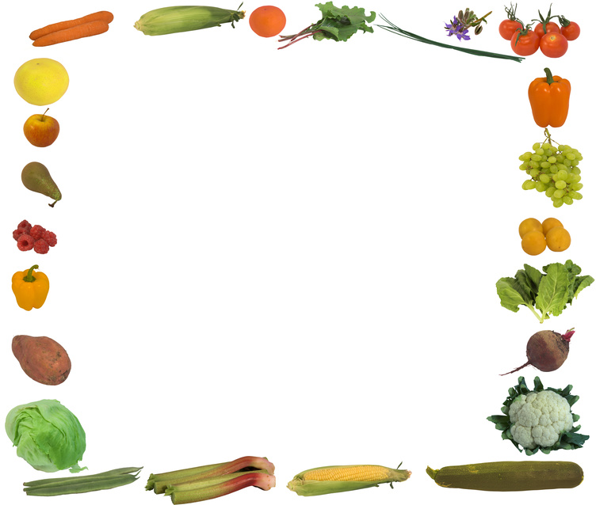

**Dr. Winters’ Optimum Weight and Fitness Plan for Life**

1. Eat approximately one pound of vegetables (fibrous carbohydrates) with each meal.  These include all green vegetables (celery, green beans, bell peppers, cucumber, zucchini, all lettuce, spinach, sprouts, broccoli, and artichokes, but not avocado), cauliflower, onions, radishes, yellow summer squash, mushrooms, turnips, and many others.  Note that potatoes, corn and beans besides green beans are not on this list.
2. Eat a small serving of complex carbohydrate (starchy carbohydrates) with each meal.  These include oatmeal, brown rice, ½ potato or sweet potato, popcorn, corn, non green beans, peas, tomatoes, and carrots.  If you must, you may have a small serving of bread, pasta or fresh fruit instead but best to stick to the list above most of the time.
3. Eat a lean protein with each meal like fish, tuna, shellfish, chicken breast,96% lean beef, pork tenderloin, turkey, and egg whites.
4. Eat multiple meals daily – best to eat earlier in the day and less at night.  Do not allow yourself to get hungry – this leads to overeating.
5. 2 – 3 times a week have something not on the plan.  These items may include alcohol, pizza, burgers and other fast foods, desserts, and restaurant food.  This feature will allow you to stay on the plan for life because you will not feel punished or restricted like a “diet”.  You can stay on this plan and enjoy occasions too!
6. Avoid eating out except for occasions in #5.  Prepare food at home with small amounts of good fat such as sesame oil or olive oil and lots of spices.  Grilling is an excellent way to prepare meat and vegetables.  Get an indoor grill for winter (George Forman or Cuisinart).  Make sure you have healthy meals planned for work or excursions
7. Use fresh or frozen vegetables rather than canned.  Costco, Meijer, and Aldi are good places to buy fresh produce at a reasonable price.  A “Nutribullet” can be purchased on the web, Costco, or other stores and is a great way to make vegetables more palatable and easier to digest. Try a spiralizer for more fun with vegetables.
8. Avoid caffeine, alcohol, pop, fruit, dairy, refined sugars and fats, frozen or packaged food (except frozen vegetables), pasta, bread, fried or fatty foods, sweets, and artificial sweeteners.
9. Drink water.  Avoid milk, pop, and fruit juices.
10. Exercise.  Best to do a combination of weight training, cardio, and core and stretching activities.  “The FIRM” or “Beach Body” home video programs are a good places to start or try the YMCA.  A personal trainer can help you design a program that you can continue on your own.
11. Try chicken, green beans and brown rice for breakfast!  Avoid the cereal crash.
12. Do not smoke.
13. If you feel hungry, increase your starchy carbs with meals.  If you want to lose more weight eat more fibrous carbs and less starchy ones.  You can always snack on veggies.
14. Enjoy better control of your health problems such as hyperlipidemia and diabetes.  You will have less dementia, vascular disease, fractures, dental disease and heart disease with this comprehensive commitment to your health.  You will be happier, more productive, and active throughout your lifetime.